**ANSWERING KEY QUESTIONS**

1. **Are survival rates and finding dead body correlated with boarding a lifeboat? Did most of survivors survive because they were rescued by a lifeboat?**

Of the 486 passengers who boarded a lifeboat, only 9 passengers’ bodies went missing and the rest survived. On the other hand, of the 823 passengers who did not board a lifeboat, only 23 people survived. These results imply that boarding a lifeboat was critical to survive the shipwreck of Titanic, but not critical to be found if deceased.

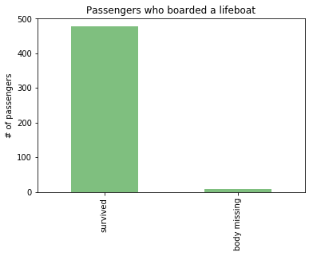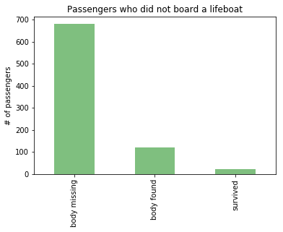

We ran an ordinary linear regression on the survival of passengers to examine the relationship between survival and riding a lifeboat after the collision. With p-value smaller than 0.000, we can reject the null hypothesis that riding a lifeboat is not correlated with survival with high statistical significance.



1. **Are survival rates and discovery of dead body correlated with gender of passengers?**

Below stacked bar graphs show that female passengers showed much higher survival rate. Even though the number of male passengers aboard was much greater than that of female (male = 843, female = 466), number of male survivors was much smaller than that of female (male = 161, female = 339). Therefore, the survival rate for female is much higher at 72.75% compared to that of male at 19.10%. Perhaps “Lady First” maritime code of conduct played a big role to show this result.

On the other hand, of the non-survivors, number of bodies found was much higher for male. Out of 121 bodies found of non-survivors, 133 were of male and 8 were of female. However, since the number of non-survivors is much greater for male, the difference in body-found rate by gender is so big. 6.3% of female non-survivors’ bodies were found, and 16.57% of male non-survivors’ bodies were found.

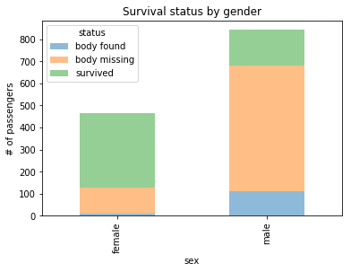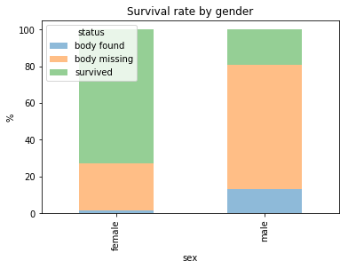

In order to confirm the relationship, we ran OLS regression on survival status. With p-value less than 0.000, being a male passenger is indeed correlated with the survival of the Titanic with high statistical significance.



1. **How are survival rates and discovery of dead body related to the age of passengers? Were children or elderly groups saved first?**

Number of survivors are the highest for age group 20-30, but this is not surprising considering that the number of passenger for that group is the highest. Looking at the survival rate instead, we can immediately notice that age group 0-10 and 50-60 show the highest survival rates. This might also be due to “Ladies and children first” maritime code of conduct taking in place. Age groups 10-20, 20-30, 30-40, and 40-50 show similar survival rates around the mean survival rate of 38%.

What’s more interesting here is relatively lower survival rates for age groups 60-70 and 70-80 at 22% and 33% each. They also show relatively higher rate of finding bodies at 30% and 33%, compared to the mean rate of 9%. This might imply that the elderly groups did not or could not escape from their cabins and were later found with the ship.

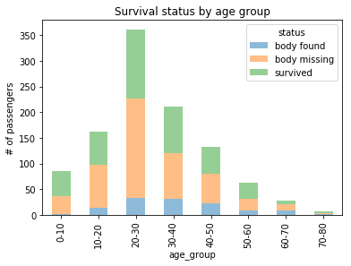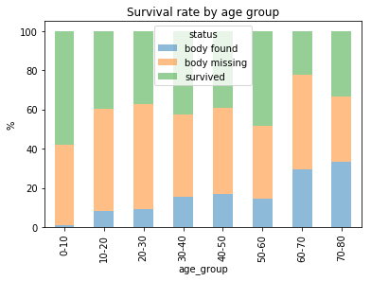

Looking at passengers and survivors both by age group and gender, we can immediately notice that survival rate is high for age group 0-10 both for male and female. Children were prioritized regardless of their gender. Unusually high survival rates for female age group 50-60 and 70-80, and unusually low survival rate for male age group of 60-70 seem to be affected by small sample sizes of 25, 1, 27, respectively.

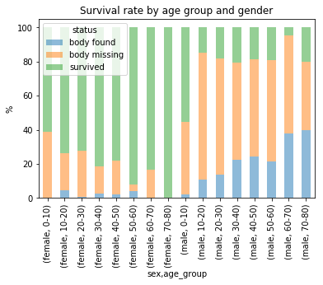

1. **Are survival rates and discovery of dead body correlated with cabin class (socio-economic status) of passengers?**

Out of three cabin classes, First class shows highest survival rate and relatively high rate of finding bodies for non-survivors at 62% and 11%, respectively, when compared to Second class (43% and 11%) and Third class (26% and 8%). It is worth noting the fact that both rates are high for one group, since this was not the case for age groups or gender. Female had higher survival rate, but much lower body-finding rate that male, and age groups that showed high survival rates showed relatively lower body-finding rate. Gathered from data so far, it is safe to say that cabin class is highly correlated with both survival rate and body finding rate. This might be explained by that First class passengers were given priority to be rescued, and therefore increased the rate for both.

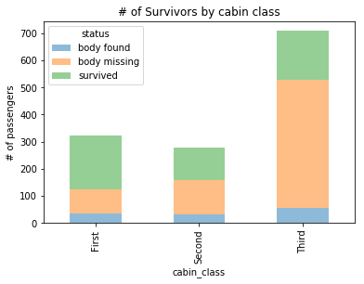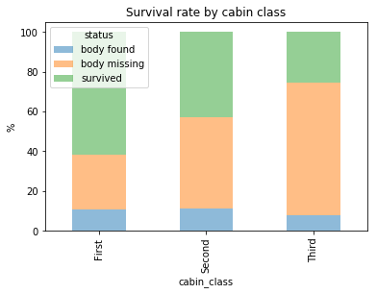

We’re now interested in cross-checking this with our key variable that showed high correlation with survival. We looked at class breakdown across with the “boat” variable.

Below stacked bar graphs show that passengers in higher class boarded lifeboats more than lower class passengers.

